MUSIC OF THE SPIRIT 3
BRASS BAND MUSIC 4
PROTEST SONGS 6
BROADSIDE BALLADS 8
A SONG OF THE CIRCUS 10
MUSIC TUITION #1 12
MUSIC TUITION #2 14
A MUSICAL LEGACY 16
THE AFRICAN MAHLER 18
THE LARGEST DANCING PLATFORM IN THE KINGDOM 19
THE OPERA SINGER AND THE MUSICAL STAR 20
PATRIOTIC SONG 21
CRYIN’ ALL DAY 22
UNITY DAY 23
PRINCE ALEMAYEHU 24
THE FISK JUBILEE SINGERS 26
MUSICAL CONNECTIONS 27
Music House Past and Present
Researchers - Joe Williams and Matthew Bellwood
Additional research by members of Music House Gospel Choir
Poster design, layout and illustrations by Wingfinger Graphics, Leeds - wingfinger.co.uk
Unless otherwise stated, all photographs have been reprinted by kind permission of Leeds Libraries, www.leodis.net
Music House Past and Present was funded by Leeds Community Foundation 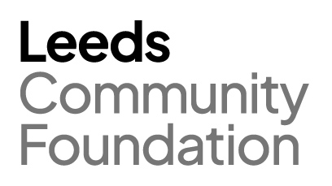

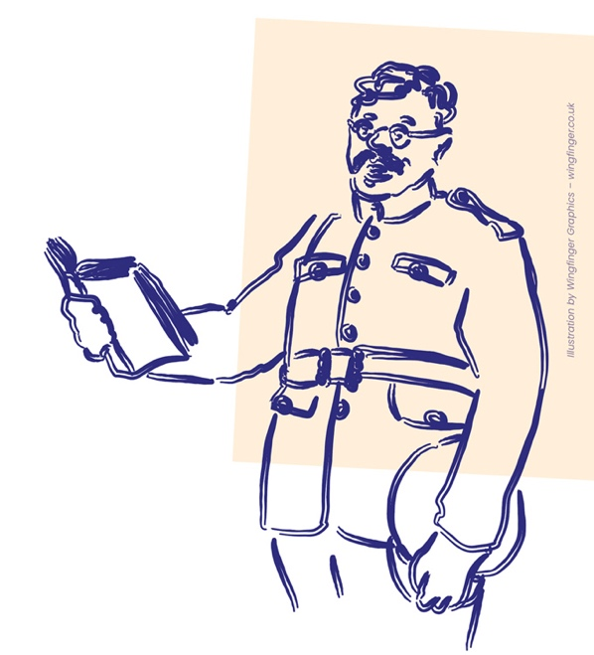
MUSIC OF THE SPIRIT
“From hand to hand the greeting flows,
from eye to eye the signals run,
from heart to heart the bright hope glows,
the seekers of the light are one.”
From ‘O life that maketh all things new’ by Samuel Longfellow (1874), included in the Unitarian hymnal Singing the Living Tradition.
Woodhouse has long been home to people from different cultures and cultural backgrounds. Perhaps one of the reasons for this is the presence of the two Universities, which have attracted students – and lecturers – from all around the world.
One of these students was Jogendra Nath Sen, who came to Leeds from India in 1910. Initially a student at the University of Leeds, where he studied engineering, he later took a job at the Leeds Electric Lighting Station in Whitehall Road. Throughout his time in Leeds, he was resident at Grosvenor Place (now demolished), just off Blackman Lane in Woodhouse.
He was one of several Indians who came to Leeds to study around this time and he became a regular visitor to Mill Hill Chapel, the Unitarian Church in City Square. Although he was a Hindu by upbringing, he joined the Chapel’s choir and struck up friendships with many of the members. Amongst them was a young woman named Mary Cicely Wicksteed, the daughter of a local engineer. It is tempting to believe that he may have numbered amongst the party described in the following article from The Yorkshire Post, dated Monday July 17th, 1911.
“On Saturday the annual excursion of the Mill Hill (Unitarian) Chapel Choir took place. A party, numbering over 60, went to Ripon and Fountains Abbey, where a most enjoyable day was spent. After viewing the Minster, the party drove in brakes to the Abbey and in the large cloister court they sang a number of part-songs. Among the listeners were two church choirs from a distance, who were so charmed with the superb renderings of the Leeds singers that they requested a repetition of several numbers, and encores were cheerfully given.”
Jogendra appears to have been well settled in his adopted home and when war was declared in 1914, he decided to join the armed forces. Like many other young men of the city, he was recruited into the newly formed ‘Leeds Pals’ Battalion. His status as a university graduate should have put him in line for a commission, but the prevailing colour bar prevented that. Despite this, he was well-liked and respected by his fellow soldiers, one of whom remembered him after the war as “the best educated man in the battalion.”
Following his recruitment, he was sent to Colsterdale for basic training and then to Egypt in 1915 to defend the Suez Canal. In 1916 the battalion was posted to France, where he saw action in the Somme offensive. He was killed on the 22nd of May that year. Although Jogendra was buried in France, his personal effects were sent home to India, to his mother and brother in Chandernagore. Amongst these were a signed photograph of Mary Cicely Wicksteed and a small book of quotations, inscribed with the message: “With the very best of good wishes in this world + after, To Jogi, my Dear brother, From his loving sister, Cis.” – a lasting reminder of the power of music to bring people closer together.
Private Sen’s name can be found on war memorials both inside and outside Mill Hill Chapel, and on the University of Leeds’s Brotherton War Memorial, in the foyer of the Parkinson Building.

BRASS BAND MUSIC
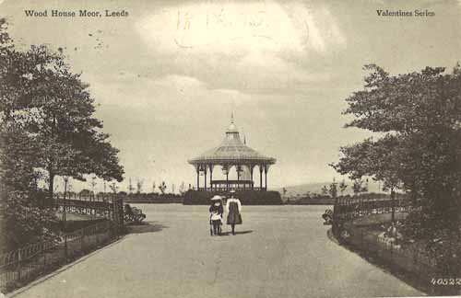

Undated but postmark is 1905. Postcard of path on Woodhouse Moor leading to the Bandstand, with two girls posing for the photograph. © Leeds Libraries, Leodis.net
At the centre of the park on Woodhouse Moor is a large, tarmacked circle, connecting the various paths which criss-cross the area. This empty space was once the site of a Victorian Bandstand, financed by Alderman William North in 1879 as a gift to the people of Leeds. Public performances of brass band music had been put on in the park since the 1850s but the bandstand provided an ideal point of focus, as well as ensuring that the performers had somewhere dry to sit if the weather was inclement.
Concerts on the moor appear to have been popular, with appearances from local and regimental brass bands drawing large crowds – though not everyone enjoyed the music. There were ongoing debates about performances on Sundays as well as opposition from some members of the community who thought that the concerts ruined the peaceful atmosphere of the park.
According to The Yorkshire Evening News (Tuesday May 14th, 1907) complaints were also received about, “the noise and indifference shown among the younger portion of the large audience, demonstrating that they do not assemble at the concerts to listen to the music.”
Many bands are referenced in newspaper reports as playing on the moor. Amongst those mentioned are The West Riding Military Band, The Leeds Forge Band and the bands of The Scots Guards, The Royal Marines and The Second West Yorkshire Royal Engineers. A report in the Leeds Mercury Weekly Supplement (Saturday July 16th, 1892), describes a children’s concert, organised by the Supporters of the Leeds Workpeople’s Hospital Fund, which featured “a choir of about 600 children drawn from various schools in the town”.
In general, the concerts appear to have been paid for by the Parks Committee, with a collection being taken during the performance, to supplement the committee’s funds, or, in some cases, to benefit local charities. It seems that the audience were not always keen to express their financial appreciation.
In the words of The Yorkshire Evening News, in 1907, “… unless the public show a better appreciation of the concerts and a more liberal spirit when passing the collecting sheets the Parks Committee may during next year have to consider whether they will be justified in contributing as generously as at present for the continuance of performances of this kind.”
Sadly, the bandstand was partly demolished in the 1940s and the metal from it used for the war effort. Some part of the bandstand seems to have remained in situ.
According to the booklet ‘A History of Woodhouse Moor’ by Ian Harker, “until March 14th, 1950, the sparrows roosted communally in an old bandstand. On that day complete demolition of the building took place, and its absence at dusk was the cause of great bewilderment to the incoming birds: individuals and little parties would repeatedly sally out to the spot in mid-air where their roosting-places used to be and then veer back again to the surrounding bushes. They finally settled down to sleep in these, and by the next evening were evidently resigned to the new position.”

PROTEST SONGS
“Rise up, women, for the fight is hard and long,
Rise up in thousands singing loud a battle song.”
From ‘Rise Up Women!’ by Theodora Mills, sung to the tune of ‘John Brown’s Body’.
There are many songs associated with the women’s suffrage movement in the UK: ‘Rise Up Women’, ‘Shoulder to Shoulder’, ‘The March of the Women’, ‘Sister Suffragette’ and ‘The Women’s Battle Song’ to name but a few. It is likely that many of these could be heard on Sunday July 26th, 1908, when Woodhouse Moor became the scene of a great demonstration.
“The proceedings commenced in Victoria Square, where a lengthy procession was marshalled. Among those present were Mrs Pankhurst, Miss Adela Pankhurst, Mrs Pethick Lawrence, Miss A Kenney, Miss Mary E Gawthorpe and Mrs Baines, and these ladies occupied positions on decorated waggons … with banners gaily fluttering, and accompanied by brass bands, the Suffragettes and their supporters proceeded to Woodhouse Moor, where a great gathering of people awaited their arrival. Upon gaining the Moor the waggons, which numbered ten in all, were drawn up in various positions, and formed convenient platforms, from which the speakers addressed the crowd...
The speaker to commence first was Miss A. Pankhurst, and for an hour and a-quarter she held the attention of a large audience, to whom she expounded the aims and aspirations of the movement. Here as elsewhere, there was little interruption, and a patient hearing was also given Miss Gawthorpe. From each platform a resolution was put, asking for the sympathy of those present for the Suffragettes imprisoned in Holloway, and calling upon the Government to at once extend the franchise to duly qualified women. The resolution was carried on a show of hands, this bringing to an end a demonstration, the success of which must have been very pleasing to the promoters.”
The Yorkshire Post, 1908.
Miss Mary E Gawthorpe, who spoke at the event, was a Leeds-based suffrage campaigner, who grew up in Woodhouse. The daughter of John Gawthorpe (a leatherworker) and Annie Eliza Gawthorpe (née Mountain), she grew up poor, working as a pupil-teacher in Bramley from the age of thirteen.
Following her speeches on Woodhouse Moor, she continued her work as an activist, heckling Winston Churchill in 1909 – an act which led to her being imprisoned and badly beaten by police. Despite bringing a charge of assault, she was arrested and sentenced to two years in Holloway Prison, during which time, she went on hunger-strike. This, along with the injuries she received, severely affected her health for years to come. She was also a socialist, magazine editor and trade unionist. Mary later moved to America, where she married in 1921. She remained politically active throughout her life.
In her autobiography, Up the Hill to Holloway, she recalls that, “… school holidays were mostly spent on Woodhouse Ridge varied by an occasional visit to the public swings in the neighbourhood of Woodhouse Moor …”

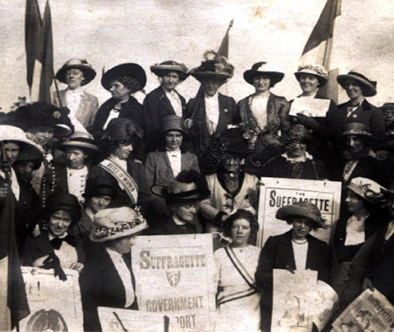

28th July 1908. Image shows a group of women carrying placards and banners as they take part in the Women's Social & Political Union's Procession to Woodhouse Moor where a huge rally was held.
© Leeds Museums and Galleries, Leodis.net

BROADSIDE BALLADS
A ‘Broadside Ballad’ is a narrative song printed on a broadside – a single sheet of paper. Dealing with a wide range of subject matter, they were hugely popular in Britain between the 16th and 19th centuries.
Broadsides were cheap to produce and buy, and one estimate suggests that by the middle of the 1600s, around 400,000 were being sold every year in England alone. Generally, only the words to the song were included, and these were sung to popular and well-known melodies of the time. Often, suggestions as to which tune to use were provided along with the words.
The style of the ballads was usually direct and down-to-earth. They dealt with the stuff of everyday life – crimes and misdemeanours, tragic mishaps, illicit love affairs, unusual events or occurrences, local legends, religion, politics and scandal. They served as a way of recording, sharing and commenting on stories of local or national interest.
There are several surviving ballads concerning events in Leeds, including one about the goings-on in Woodhouse Lane and on the moor through which it ran. The words give a flavour of the kind of place the moor used to be, before it was bought by Leeds Corporation and turned into the city’s first public park in 1857. The tone of the song is somewhat ribald, and it ends with an unwanted pregnancy. The full version can be found in Leeds Describ'd: Eyewitness Accounts of Leeds 1534–1905 by Peter Brears and Ann Heap (Breedon Books Publishing Co Ltd, 1993).

The Ballad of Sunday Night (c.a. 1850)
I’m about to sing a stunning song,
And yet the subject it’s not long,
It’s all about the funny sights –
In Woodhouse Lane on a Sunday Night.
One half of the people of Leeds be near,
Between four and ten are walking there,
All other walks are deserted quite,
For Woodhouse Lane on a Sunday Night.
Old bachelors they are strutting away,
Laughing and chaffing with maidens gay,
And sour old maids too there you’ll find,
With their little pet dogs trotting behind
And soldiers in red coats so gay
With factory lasses are marching away,
Bragging of how they can sing and fight –
In Woodhouse Lane on a Sunday Night.
To take a walk I do declare,
All men and women do repair,
Smart young fellows dressed up so grand,
With a cut away coat and stick in hand;
And servant lasses fat and plump,
With a great big bustle on their rump,
Rambling out in great delight
Along the road on a Sunday Night.
Above the barracks there you will meet,
With naughty girls from Regent Street,
Who up to your elbows close will steer,
And whisper softly “good night my dear,”
And if with them you dare to stop,
They’ll gammon you to stand a drop,
And they’ll diddle you out of your cash all right,
In Woodhouse Lane on a Sunday Night.

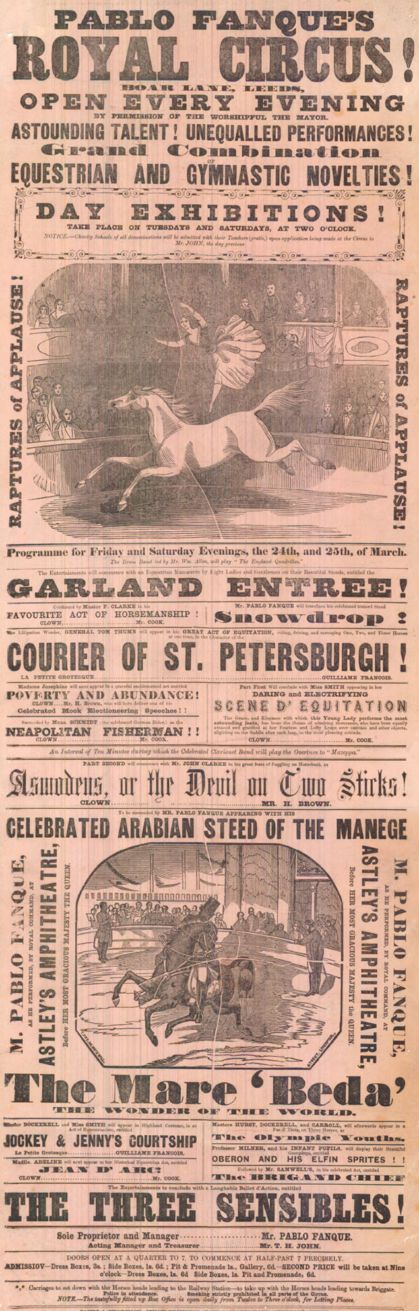
A SONG OF THE CIRCUS
“For the benefit of Mr. Kite,
there will be a show tonight on trampoline.
The Hendersons will all be there,
late of Pablo Fanque's Fair, what a scene.”
Photo © Leeds Libraries – Playbills Collection
These lyrics, written by John Lennon, are taken from The Beatles’ song ‘Being for the Benefit of Mr Kite’ on the 1967 album Sgt Pepper’s Lonely Hearts Club Band. They were inspired by a poster for Pablo Fanque’s Circus, which Lennon discovered in a Sevenoaks antique shop. Pablo Fanque was the stage name of William Darby, a famous Victorian performer and entrepreneur who, as far as history records, was Britain’s first black circus owner.
Born in Norwich in 1810, William Darby was one of five children belonging to John and Mary Darby. His father was of African origin and born in Norwich too, in 1776, which makes William at least second-generation black British. At the age of eleven, he was apprenticed to a circus owner named William Batty. He adopted the stage name Pablo Fanque and began to learn the acrobatic and equestrian skills that would make him a household name in Victorian Britain. In his early twenties, he married a woman named Susannah Marlaw, the daughter of a Birmingham button-maker. She bore him two children, both of whom followed their father into the circus.
In the words of The Illustrated London News (March 20th, 1847), “in 1841, he began business on his own account, with two horses, and has assembled a fine stud of horses and ponies at his establishment at Wigan, in Lancashire, in which county Mr. Pablo is well known, and a great favourite.”
He was also much loved in Yorkshire performing many times in Leeds at sites around the city and its outskirts. In 1846, Pablo packed out Woodhouse Moor for the Repeal of the Corn Laws celebrations. The show was a huge spectacular, celebrating an event that made food more affordable for the working classes.
In 1847, he performed before Her Majesty Queen Victoria at Astley’s Amphitheatre in London. From this point, he toured the country as ‘Pablo Fanque’s Circus Royal’.
Unfortunately for Pablo, tragedy was waiting in the wings. In 1848, the wooden scaffolding holding up his circus arena collapsed during a performance in King Charles Croft in Leeds. Susannah was fatally struck by a pair of falling planks. She was buried in the nearby Woodhouse Cemetery. Thankfully, there were no other fatalities. Pablo marked his wife’s grave with an impressive memorial stone, knowing that he too would join her when his time came.
The loss of his wife was a major blow for Pablo but, nevertheless, he married again, on this occasion to Elizabeth Corker, a circus rider, with whom he had three further children. In a major comeback tour in 1854, he attracted many exciting international acts, boasting “one of the largest companies of equestrians!” The audiences at the show on Boar Lane, Leeds, were also invited to hear “Pablo Fanque’s sax-horn, cornopean, and string bands.”
However, despite his fame and evident popularity, Pablo’s later years were hard. The arrival of American circuses in Britain, brought stiff competition and he began to run up heavy debts. In 1859 he was declared bankrupt. Nevertheless, he carried on performing throughout the next decade until his death from bronchitis, in 1871.
On his death, his body was brought to Leeds. The newspapers report that a crowd of 10,000 people lined the streets of the city from the train station to the graveside to say farewell.

MUSIC TUITION #1
Music House has had several different identities over the years. It started life as the Leeds College of Music in 1894, transformed into the Yorkshire College of Music and Drama in 1965 and rebranded as Music House in 2021. Its story starts in the late Victorian era, with a musical family called the Haddocks…
George Haddock (7 August 1823 – 12 September 1907) was an English violinist, and professor of music. Born in Killingbeck in Leeds, he was extensively involved in the Leeds and Bradford music scene during the mid to late 19th century. By 1853 he was established as a professor of music and taught many thousands of students, including a young Frederick Delius. In 1844, George married Ann Marston and together, they had seven children. Among them were Edgar Augustus and George Percy Haddock, both of whom went on to become successful musicians.
George founded the Leeds College of Music (now Music House) in 1894, together with his sons, and was the college’s first principal. The original premises were on Cookridge Street in Leeds City Centre. George Haddock died in 1907 at the age of 84 and a postcard showing the entrance hall of the College, dated to the same year, has the principal as Edgar Augustus Haddock and the director as George Percy Haddock.
The College expanded quickly, opening branches in Bradford and Skipton. In 1905, the Leeds College of Dramatic Art opened as an adjunct to the College of Music. It was officially inaugurated by the actress Ellen Terry. The famous opera singer Adelina Patti was amongst those attending the opening. The following year, the College began to offer classes in arts and crafts, including “pyrography, woodcarving, repousse work, stencilling, oil and watercolour work.” (The Leeds and Yorkshire Mercury, June 21st, 1906.)
The college continued to go from strength to strength, gaining positive reviews in the local press for their education work and for the quality of their public concerts and music evenings. Edgar Haddock also championed drama and was responsible for the creation of the Leeds Little Theatre in the College’s Cookridge Street premises.
In 1919, Mr Victor Helliwell, began his long association with the College as a music teacher, specialising in voice. A well-rounded man, he had formerly been a schoolteacher and a lecturer in Horticulture for West Riding County Council. As well as performing publicly as a singer, he was a keen footballer. In 1925, he became the leader of the Leeds College of Music choir.
In 1926, Edgar Augustus Haddock passed away at the age of 67. His son, Mr G Marston Haddock, took over as principal, remaining in post until 1932 when he moved to the United States. Victor Helliwell was appointed as his deputy and ran the College of Music in his absence. The same year, the college moved to new premises at Cavendish Lodge on Cavendish Road, close to the University of Leeds.
In 1937, tragedy struck. George Percy Haddock was accidentally killed after being hit by a lorry on Woodhouse Lane. He was 76 years old.
Victor Helliwell was officially appointed principal of the College in December 1940. His appointment marked the end of an era. For three generations, the Haddock family had run the Leeds College of Music and established it as an important part of the city’s music scene. As individuals, they seem to have been well-liked and well-regarded by their colleagues, students and the general public. The continued existence of the college today, under its new title ‘Music House’, is no doubt due in part to the firm foundations laid down by the Haddocks.

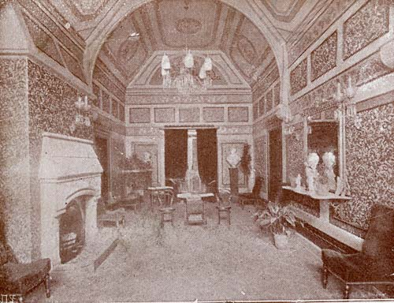

5th October 1907. This postcard shows the entrance hall at Leeds College of Music or Yorkshire College of Music and Drama (now called Music House) on Cookridge Street. There is typewritten message "Mr Vincent will be glad if you will be here at 12 for your lesson", signed 5/10/07 by the principal Edgar Augustus Haddock & the director George Percy Haddock. © Leeds Museums Service

MUSIC TUITION #2
In 1964, the College of Music suffered a serious loss. Mr Victor Helliwell, who had been principal of the College since 1940, passed away after a period of illness. Helliwell appears to have been an inspiring and much-loved teacher.
According to a letter in The Yorkshire Post on October 1st, 1964: “Almost a generation of singers has reason to be grateful to him for his painstaking and inspired teaching and for his great knowledge of vocal technique. As principal of Leeds College of Music, he was always ready with words of encouragement to students and teachers alike and created a happy atmosphere of mutual confidence. His outstanding characteristics were his glowing idealism and undeviating honesty, which could not fail to influence those who came in contact with him. During the last few years, he faced ill-health and other misfortunes with great courage and undimmed faith. His place will indeed be difficult to fill – Yours etc, Audrey Cooke, Leeds 8.”
Victor Helliwell’s passing left the College in a difficult situation. He had died intestate, and this raised questions about the College’s legal status. As a result, the College lost the lease on its premises – a large house called Dunearn at no 16, Wood Lane, Headingley – where it had been based since 1947, and reconstituted as a charity, ‘The Yorkshire College of Music and Drama’, in 1965.
The next few years were challenging ones, but the College kept on going, thanks to the efforts of its dedicated teaching staff. A particular problem was the lack of a permanent base of operations, but help was at hand in the formidable form of Lillian Stiles-Allen. A gifted concert soprano, who had performed at recitals and festivals nationwide, she had been working with the College as a singing teacher since moving to Leeds from London.
On arriving in the city, in 1941, she purchased a house to live in – no 19 Shire Oak Road in Headingley. She lived here with her third husband, Sidney George Jeffries-Harris, her son, Michael, and a live-in housekeeper called Jessie. Although she continued to give occasional performances, from this point on, she concentrated on teaching. Alongside her work with the Leeds College of Music, she also took in private pupils. Amongst them was a young Julie Andrews, who would often come up to Leeds on the train to work with “Madame Stiles-Allen” in the 1940s and early 1950s.
Although she left the city in 1956, Lillian Stiles-Allen kept in touch with the College, and offered them the use of her property on Shire Oak Road. The building, a converted farmhouse, was an ideal location, and the College remained there until 2010. Generous to the last, Lillian left a large bequest to the College in her will, which allowed the institution to purchase the building outright in 1982.
Since 2010, the college, has been based at St Mark’s House, 1 St Mark’s Avenue, Woodhouse, Leeds. It changed its name to Music House in 2021.

Several of the college’s students have gone on to have professional careers as actors and musicians. In 2025, one of the college’s students, Zak, reached the final of The Piano, a Channel 4 programme in which amateur musicians are invited to publicly perform on street pianos in the concourses of major UK railway stations.

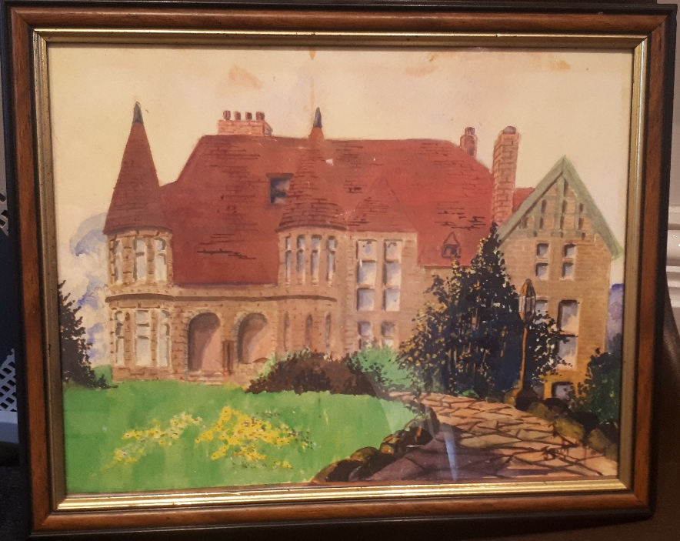
Dunearn, 16 Wood Lane, Headingley

A MUSICAL LEGACY
Standing alone on Woodhouse Moor is an enormous stone statue, erected in memory of Henry Rowland Marsden. Marsden was a former Lord Mayor of Leeds who worked his way out of poverty through his aptitude for engineering. Born in Holbeck in 1823, he went to work at the age of seven and had various jobs in factories around the local area. He had no education, outside of Sunday School, but taught himself to read at the age of twelve and began to study the principles of mechanical engineering. At fifteen, he was apprenticed to a toolmaker and began to make improvements to machinery at his place of work. His first original invention was a flax spinning machine. Unfortunately for Henry, his employer took credit for the design and made a great deal of money from it.
Marsden married Sarah Hawling, the daughter of a local butcher. In 1848, the couple sailed to America. They settled in Connecticut and here he created the invention that would bring him lasting fame – the stone crusher. The invention did what it said on the tin, providing high quality aggregate for building roads and railway lines. This was in high demand at a time when America and Europe were rapidly developing their transport infrastructure. His patent on the design meant that he made a fortune. He also worked on a wide array of other machines and devices. These included improvements to steam engines, sugar mills and industrial pumps and lathes.
In 1858, a devastating fire broke out in Marsden’s business premises – premises where his family also lived. His wife and four children only narrowly escaped the blaze and Marsden himself nearly died while rescuing his four-year-old son. The family lost all their belongings and much of their business stock.
Despite this, he kept on working and his situation soon improved. In 1862, the family decided to return to Britain. The same year, he exhibited a new machine at an exhibition in London. The device, the ‘New Patent Cubing Jaw’, was a great success. Now an extremely wealthy man, Marsden settled in Leeds and set up shop in Holbeck. His company HR Marsden Limited was based in Soho Engineering Works in Sweet Street. Legend has it that Marsden would sit in his office every day at the side of the stockyard gates and hand out bread and shoes to anyone who needed them.
He became a city councillor in 1866, representing the Holbeck Ward, and was Mayor of Leeds in 1873 and 1874. During this time, he initiated the Leeds Triennial Musical Festival. The first festival had been held in 1858, to celebrate the opening of Leeds Town Hall by Queen Victoria. The second festival was held in 1874, and the festival took place every three years from then on. The final festival was held in 1985, but the Leeds Festival Chorus, which was formed to sing at the festivals, continues to exist.
Marsden died unexpectedly, in 1876, at the age of fifty-three. £10,000 was raised by public subscription for the erection of a statue in his honour. The resulting artwork, by Leeds sculptor John Throp, stood at the junction of Woodhouse Lane, Merrion Street and Albion Street. It was moved to its current position in 1952. The section of moor it stands on became known as Monument Moor because of the statue’s presence.

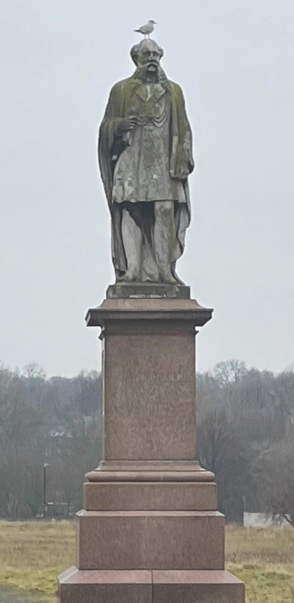
Henry Rowland Marsden monument on Woodhouse Moor. Photo by Joe Williams

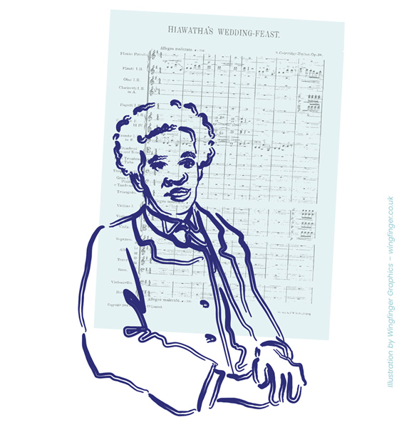
THE AFRICAN MAHLER
Samuel Coleridge-Taylor was one of the foremost composers and conductors of his day. He was born in London, in 1875, to a British mother and a West African father. His father, Daniel Taylor, was a medical doctor, who hailed from Sierra Leone. He returned to home in the same year his famous son was born – possibly without ever knowing that his girlfriend, Alice, was pregnant.
As a child, Coleridge-Taylor was a prodigy on the violin, and his musical talents were noticed early. He gained a scholarship to the Royal College of Music, where he studied from the age of 15. He went on to become a hugely successful composer. His most famous composition was Hiawatha’s Wedding Feast, based on HW Longfellow’s epic poem The Song of Hiawatha. The work became popular with choral groups, and the piece was staged many hundreds of times across Britain, Europe and America.
In 1901, Coleridge-Taylor was invited to compose a new piece of music for the Leeds Triennial Musical Festival, which took place at Leeds Town Hall. The conductor for the piece was Charles Villiers Stanford, who had taken over Festival duties from Sir Arthur Sullivan (of Gilbert and Sullivan fame). Stanford had taught composition to Coleridge-Taylor at the Royal College of Music and had also conducted the first performance of Hiawatha’s Wedding Feast. Sadly, the composition, The Blind Girl of Castél-Cuillé, was not especially well-received. Much of the criticism was focused on Coleridge-Taylor’s choice of source material which was, once again, a poem by Longfellow.
Coleridge-Taylor continued composing and conducting for the rest of his life. He never lost his love for The Song of Hiawatha, and the poem inspired two further cantatas, The Death of Minnehaha and Hiawatha's Departure as well as a ballet and an overture. Between 1924 and 1939, a dramatized version, Scenes from the Song of Hiawatha, was staged at the Royal Albert Hall. The programme was presented for two weeks annually until the advent of World War Two. One of the featured performers was Lilian Stiles-Allen, who famously sang the role of Old Nokomis. Stiles-Allen would later become a teacher at the Leeds College of Music.
Though a quiet and unassuming man, Coleridge-Taylor became a determined advocate for racial equality and colonial freedom. He strongly identified with his African heritage and was interested in the work of other artists of colour. He attended performances and was inspired by the Fisk Jubilee Singers on their visits to Britain. He made three tours of the United States, in 1904, 1906, and 1910. During his first visit, he was received by the president, Theodore Roosevelt, at the White House and met civil rights campaigners such as Booker T. Washington. It was in America that he received the soubriquet “the African Mahler,” from white musicians he met in New York.
Coleridge-Taylor died in 1912 at the age of only 37, but his work remains popular. The Hiawatha Ballet Suite is still performed regularly all around the world. On his death, his widow Jessie was granted an annual pension of £100 by King George V – a substantial amount that bears witness to the high regard in which he and his work were held. His two children, Avril and Hiawatha, were both musicians. Avril also performed in Leeds, conducting her father’s most famous composition at Leeds Town Hall on the afternoon of Sunday May the 30th, 1948.

THE LARGEST DANCING PLATFORM IN THE KINGDOM
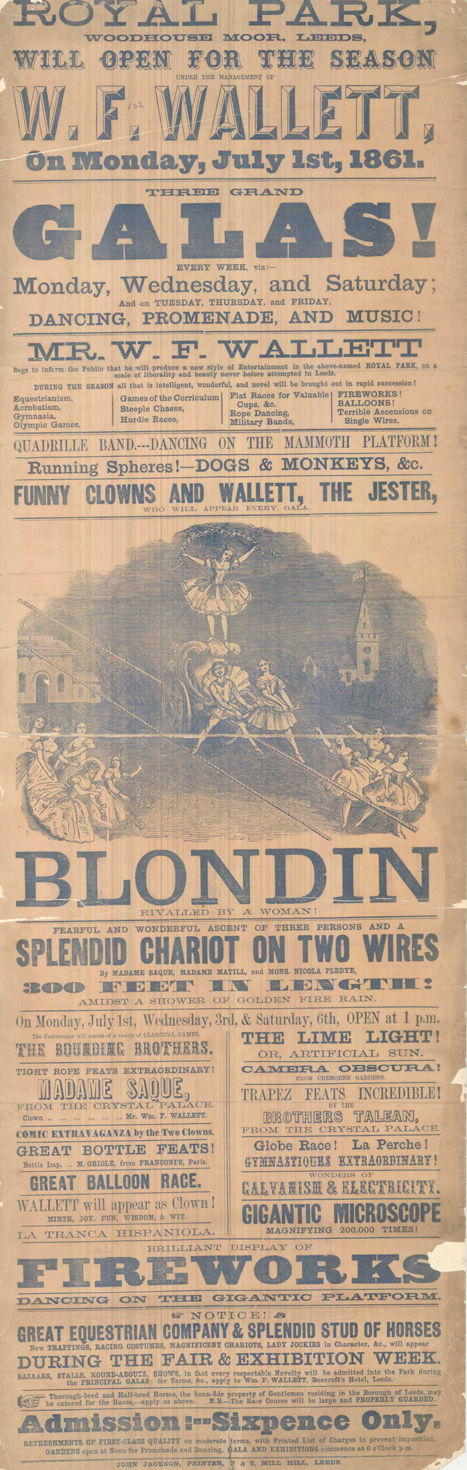
“Mr Thos. Clapham, the proprietor of the Leeds Royal Park, was, at the Leeds Police Court, on Saturday – before Mr Luccock and Mr Tennant – again summoned on two charges of permitting music to be performed on his grounds without a licence.”
The Yorkshire Post and Leeds Intelligencer, August 3rd, 1868
Photo © Leeds Libraries – Playbills Collection
The Leeds Royal Park was a public pleasure garden that existed in Leeds between 1858 and 1874. The park was opened and run by Tommy Clapham (1817–1895), a local entrepreneur, who had previously had the lease on the Leeds Zoological and Botanical Gardens in Headingley.
The park, adjacent to Woodhouse Moor, was open every day, and hosted various galas and festivals throughout the year. The Grand Whitsuntide Festival in 1869 featured musical performances by ‘The Celebrated Spanish Minstrels’, ‘Miss Lizzie Watson … the most popular and characteristic vocalist of the day,’ and ‘Mr Reuben Hyams … in his comic protean sketches and songs’. There were ‘bands of first-class musicians’ drawn from the local area, including The Royal Park Band, The Bramley Band, The Armley Band, and The Hunslet Band, while the Leeds Glee and Madrigal Union sang ‘fifteen beautiful glees … at frequent intervals, commencing at 2:30PM each day.’ These performances sat alongside other events, including races, games, illuminations, firework displays, clown shows, tightrope walkers and hot air balloon ascents. (The Bradford Observer, Thursday May 13, 1869.)
Tommy was a popular local character; a snappy dresser with a flair for self-publicity, he was a member of the local council from 1865 to 1871. The Park attracted visitors and appears to have been popular, but the overheads, including the large mortgages that Clapham had taken out to secure the land, kept growing. As a result, he was continually short of funds and was unable to make the park turn a profit. Adding to his woes was a series of fines for allowing music and dancing to take place at the park without a licence.
Clapham appeared before the courts on numerous occasions to dispute the charges, though the rulings all seem to have gone against him. Despite this, he continued to promote dances and other musical performances on what was claimed to be “the largest dancing platform in the kingdom.” A particular bone of contention appears to have been the programming of music on a Sunday.
Having finally defaulted on his mortgage payments, Clapham’s creditors foreclosed, and his assets were liquidated in 1871. Clapham moved to London where he took over the running of the Royal Surrey Gardens but continued to run the Royal Park remotely. Sadly, he lost his licence to operate, after being fined for allowing gambling on games of knurr and spell (a traditional English ball game). Much of the park was sold off in 1874, to make way for residential building work, but what was left continued to operate under new management, as Leeds Horticultural Gardens, until 1885.
There are few traces of the park left today, though its presence is remembered in the names of the streets that occupy its former site: Royal Park Road, Terrace, Avenue, View, and Mount. Brudenell Road was formerly called Clapham Road, after the park’s founder, though this was changed by the local council, following his fall from financial grace.

THE OPERA SINGER AND THE MUSICAL STAR
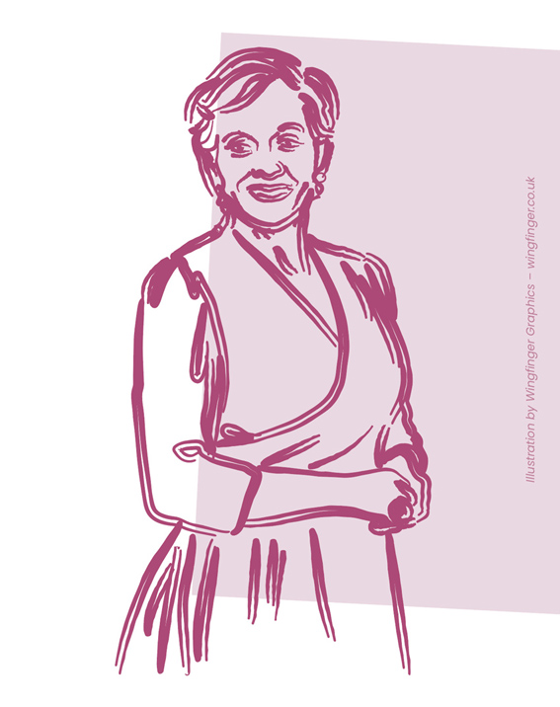
In the late 1960s, Julie Andrews was one of the biggest stars in the world. By this time, she had wowed theatre audiences in productions of The Boy Friend, My Fair Lady and Camelot and starred on film in Mary Poppins, The Sound of Music, The Americanization of Emily, Torn Curtain, Hawaii and Thoroughly Modern Millie. Andrews had the world at her feet, but she always maintained that much of her success was down to the kind and patient tutelage of her singing teacher, Lilian Stiles-Allen (1890–1982), who she always referred to as ‘Madame’. They had been introduced by Andrews’ stepfather, who had been one of Madame’s former students. They began their work together in London in 1944 when Julie was only nine years old. Madame was based in Leeds at this time but travelled to London every week to teach. When she decided to remain in Leeds permanently, the young Julie would travel up by train to stay with her. In her autobiography, Andrews describes Madame’s house on Shire Oak Lane in Headingley.
“‘The Old Farm’ had a giant kitchen that doubled as a dining room, with an Aga cooker and a large fireplace. The furniture was old but comfortable, with loose floral-patterned slipcovers on the sofas and chairs. There was an authentic spinning wheel in the big, main hallway, and its spools and treadle, evoking another era, fired my imagination. The halls were lit with gas lamps, their flames sputtering above the tiny gas jets. A vast, upstairs music room contained bookcases piled high with books and files, her big, grand piano, and an old, hand-cranked phonograph on which we would listen to 78-rpm records of Caruso, Giglie, Galli-Curci and Adelina Patti. The room wasn’t used much, the main reason being the cost of heating in the bitterly cold, damp winters. There was a smaller teaching room right next to it, with an upright piano and an electric fire, and this was where Madame primarily worked with her students.”
Madame appears to have been a wonderful teacher – albeit one with a distinctive physical appearance. In Andrew’s words: “She was a short, very stout woman, with thick ankles, an ample backside, and a heavy bosom. There was a sort of ‘pouter pigeon’ look about her … Always bejewelled, she dressed in long skirts to her ankles, and sensible lace-up shoes on tiny feet that looked too small to support the frame above. She walked with a strong cane and often donned a wonderful velvet cloak and beret. Her pretty face had several jowls, but her eyes were lovely … She was imposing, yet gentle and kind, and she had the loveliest, most mellifluous speaking voice.”
Andrews credits her teacher with improving her voice, as well as her confidence, self-esteem and work-ethic. “During those lessons, Madame gave me a valuable piece of advice, which has stayed with me over the years. ‘Julie,’ she said. ‘Remember: The amateur works until he can get it right. The professional works until he cannot go wrong.’”
Andrews remained in contact with Madame for the rest of her life. Her childhood teacher kept on coaching her well into adulthood. She helped her work on the songs for her stage appearance in My Fair Lady in 1956 and visited Julie at her home in California when her film career was beginning to take off. Through their friendship, Andrews was, for a while, the patron of the Yorkshire College of Music and Drama (now Music House), and funded a scholarship for the singing student with the greatest promise.
All quotations are taken from Home: A Memoir of my Early Years by Julie Andrews (Hyperion, 2008).

PATRIOTIC SONG
In 1858, Queen Victoria came to Leeds, to open the newly built Town Hall. During her visit, she stayed at Woodsley House, the home of Sir Peter Fairburn, the mayor of Leeds, whose statue now stands on Woodhouse Moor. On the morning of the 7th of September, the Queen’s carriage processed to the moor, where she was met by a massed assembly of 32,110 scholars and teachers from 133 Sunday schools.
“Two galleries, for the accommodation of the 32,000 scholars and teachers who took part in the demonstration, were erected by the Town Council in an exceedingly suitable position on Woodhouse-moor. They were both 166 yards in length. … the schools were arranged in nine divisions according to locality, each division having its separate place of meeting, and its general, captain and lieutenants … The scholars began to assemble at the galleries before seven o’clock, the first division arriving at the moor about twenty minutes before that hour. The last division of scholars took up their positions on the galleries about nine o’clock, when the sight was truly magnificent and imposing. The band engaged by the Executive Committee was placed near the centre, and performed a selection of music as the children assembled. Every portion of the reservoir bank … and those portions of the moor accessible to the public, were occupied by thousands upon thousands of persons who waited patiently for nearly two hours … to catch but a glimpse of their much loved Queen, and also to be partakers in the Sunday-school demonstration.
At a quarter past nine o’clock, the first hymn, commencing, ‘Oh worship the king, all glorious above‘ (Hanover), was sung by the scholars in an impressive manner, Mr. Longbottom discharging the duties of conductor with great discretion and ability. The second hymn, ‘God of mercy, throned on high,’ was sung shortly afterwards to the tune ‘Innocents,’ when an intimation was received that her Majesty, who had been expected a few minutes after ten, did not leave Woodsley House until after that hour. This alteration in the programme necessitated the repetition of the hymns, but no one having the least love of harmony, could offer the slightest objection to listening to so unique a concert.
At about five-and-twenty minutes to eleven, the approach of the military escort told that her majesty had left Woodsley House, and … having entered Woodhouse Moor, her Majesty passed between the galleries amidst an ovation of overpowering plaudits, and on reaching near the centre, the carriage stopped. The Queen, who seemed exceeding well-pleased, repeatedly acknowledged the cheers from the thousands of little voices in the galleries, and from the mass of people on every side. ... As far as the eye could reach on either side was a sea of human heads, the owners of which were cheering with all their might…. The demonstration of loyalty having to some extent subsided, the signal was given to sing the National Anthem, and the children poured fourth from their young fresh voices, ‘God save the Queen,’ with a charming pathos and melody which the most gifted choristers of the opera might in vain attempt to imitate. People were not only delighted, but deeply moved; and the countenance of her Majesty showed how much pleasure she experienced in listening to the artless music of her youthful subjects.
The National Anthem having been completed, the Royal carriage was driven off, followed till it was out of sight by the repeated acclamations of the children and those surrounding them. After a brief interval, the children were dispersed; but it will be long before any of them will forget the enjoyment they experienced on the occasion of the visit of the Queen to Leeds.”
The Nonconformist, September 15th, 1858.
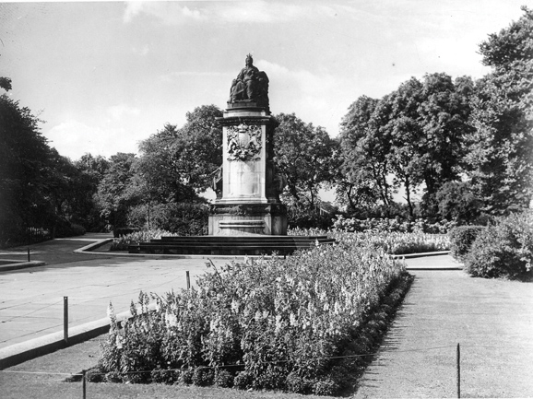
Undated, Statue of Queen Victoria on Woodhouse Moor surrounded by paved pathways and flower beds. Taken in the mid-1900s. © Leeds Civic Trust (F256), Leodis.net

CRYIN’ ALL DAY

In 1985, the sound of a 1920s jazz band, led by a soaring, if slightly melancholy cornet, signalled the arrival on our TV screens of one of the 80’s best-loved comedy dramas. The tune in question was an arrangement of ‘Cryin’ All Day’ by Frankie Trumbauer and His Orchestra, performed by Kenny Baker and the Frank Ricotti All Stars.
The Beiderbecke Affair was a six-part ITV comedy-drama, created by jazz-loving dramatist Alan Plater, and set in contemporary Leeds. The show focused on a pair of teachers, Jill Swinburne and Trevor Chaplin, played by Barbara Flynn and James Bolam. Over the course of the series, the pair become entangled in a bizarre plot involving local government corruption. The story begins when Trevor tries to buy some jazz records from a beautiful blonde woman, who claims to be raising money for a cubs’ football team.
The records in question are recordings of the music of Leon Bismark "Bix" Beiderbecke (1903 – 1931), an American cornet player, pianist and composer, considered to be one of the most influential jazz musicians of the 1920s.
In the words of Bolam’s Trevor Chaplin, Beiderbecke was, “the first great white jazz musician. Cornet player born in Davenport, Iowa, March 1903. Drank himself to death. Died August 1931, aged 28. Amazing musician. They say his playing sounded like bullets shot from a bell.”
Much of the show was filmed on location in Leeds, with Woodhouse featuring prominently. Locations used in the series include:
- Gateway Church (formerly St Mark’s Church) in St Mark’s Lane, which stood in for the parish church of St Matthew, home to Big Al and Little Norm’s black market business enterprise.
- 67 Clarendon Road, which was used as the location for Trevor’s flat.
- The remains of a demolished street off Hartley Crescent / Glossop View, now redeveloped as a green space with grass, trees and benches.
The Beiderbecke Affair proved popular with viewers and spawned two sequels, The Beiderbecke Tapes and The Beiderbecke Connection, both of which feature many familiar locations. The series is available on DVD, and the soundtrack has been released separately as The Beiderbecke Collection.
“There are only two kinds of people in this world: Those who hear the music and those who don't.”
Trevor Chaplin, The Beiderbecke Connection

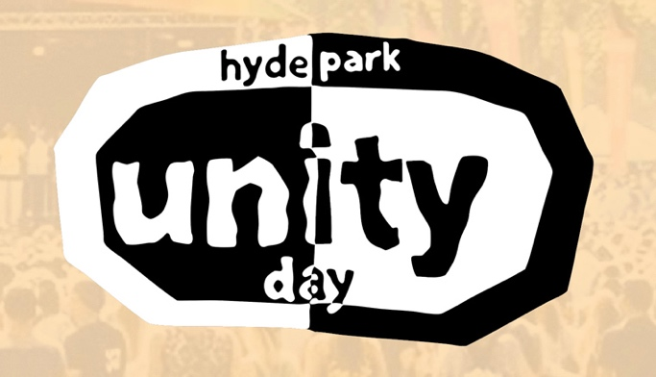
UNITY DAY
On the 10th of July 1995, two consecutive nights of community unrest took place in the Hyde Park area. The Jolly Brewer pub on Hyde Park Road (formerly The Newlands) was burnt down. Eight cars on the roads nearby also went up in flames. The incident was recorded in the press, both local and National, as a riot, but the unrest sprang from ongoing issues in the area. Crime was on the rise due to poverty and residents felt that there was little positive in the area for young people to do, while the young people themselves felt that they were being profiled and harassed by the police – tactics that proved divisive and led to further troubles.
In the wake of these events, the Hyde Park Residents Association was formed. Their intention was to try and change the negative view of the area that was being promoted in the press and to highlight the positive aspects of life in Hyde Park for those living, working and studying there. One of the strategies they came up with was the creation of Unity Day – an opportunity for local people to come together to share their talents, enjoy music, food, dancing, craft and art activities. The first iteration of the event took place on Saturday the 31st of August 1996.
“Business, local organisations, Leeds University and Leeds City Council have thrown financial backing behind Unity Day, which organisers hope will ‘enhance community spirit’ and show the people of Hyde Park that ‘they live in an area they can be proud of.’ The ten-hour event will begin at noon in Hyde Park itself with live bands and DJs on a main stage, four marquees, an It’s a Knockout competition, a children’s circus and dozens of stalls.”
The Yorkshire Post, August 29th, 1996
Since then, Unity Day has gone from strength to strength. The various bands, musicians and artists who contribute their time and talents to the event all have connections to the local area and offer their time for free – as do the members of the organisation committee.
“A community came together despite the downpours on Saturday for a summer festival of fun. Hyde Park Unity Day began six years ago in the wake of riots in Hyde Park, Leeds, and has built on its reputation each year. Most of the rain had cleared by the time the festival began at noon, and hundreds of visitors arrived on Woodhouse Moor for a feast of entertainment showcasing home-grown talent which included more than 25 live music acts playing between mid-day and midnight, as well as a whole army of DJs, craft demos, children’s events and stalls.”
The Yorkshire Post, August 6th, 2001
In 2024, the event took as short hiatus, but the event returned triumphantly in 2025.
“Hyde Park Unity Day was cancelled last year after a new committee took charge but returned to Woodhouse Moor yesterday (Saturday) to the delight of residents. The daily celebration of the vibrant LS6 area regularly sees thousands of people turn out to enjoy the live music, markets and events taking place, and this year was no different. The weather was on our side too as people gathered in the park to enjoy the dog shows, freshly made food, locally brewed beers and friendly chit chat with those they live with.”
www.yorkshireeveningpost.co.uk, August 10th, 2025

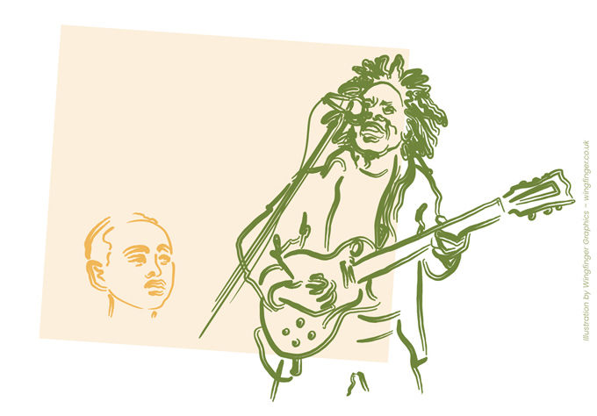
PRINCE ALEMAYEHU
Prince Alemayehu Tewodros, a direct heir to the throne of Abyssinia, passed away in Headingley in November 1879. The son of Emperor Tewodros II and Empress Tiruwork Wube, he was born on Britain’s St George’s Day, in 1861, in an Ethiopia that had St George as a venerated saint long before Britain. Ethiopian Christianity is ancient and older than Roman Christianity and its music and other African rhythms are central to the development of Rastafarianism and reggae music in the West Indies.
The story of Alemayehu’s arrival in Leeds begins in 1863. Seeking to defend his Christian kingdom from incursions from Egypt, Alemayehu’s father wrote to Queen Victoria, asking for weapons and military aid. The British Government ignored the letter, feeling that an alliance with Tewodros would not be politically advantageous. Three years later, having received no response, Tewodros grew weary of their delays and seized the British consul and his staff as hostages. They were imprisoned in his fortress at Magdala.
Attempts at negotiation failed and, eventually, the British dispatched an expeditionary force of 12,000 troops to Abyssinia. After a short and unbalanced battle, followed by the widescale looting of Magdala by British soldiers, it was reported that Emperor Tewedros died by his own hand in 1868, rather than submit to defeat by the British forces. It is worth noting that over one hundred artefacts were taken from Abyssinia at this time – only three of which have since been returned. The rest remain in the possession of the British Royal Family, the British Library and the British Museum.
Tewodros’s queen, the Empress Tiruwork, died shortly afterwards, of lung disease, leaving their only son, and heir to the throne, an orphan. As a result, Alemayehu was also removed from his homeland. The prince was placed in the care of a young army officer named Captain Tristram Speedy. He arrived in Britain at the age of eight or nine and lived for a time with Speedy and his wife, both in Britain and in India, where Speedy spent time as a colonial official.
Queen Victoria took a special interest in the young royal and kept a close eye on his progress – as did the British government – who eventually decided that Alemayehu should be given the benefit of an English education. Ironically, this was something that his father, Tewedros, had once hoped for. Alemayehu was sent as a boarder to Rugby School and then to Sandhurst Military College, where he sadly began to show signs of stress and mental strain. Needing some time away from the college, Alemayehu asked to spend time with Cyril Ransome, his favourite tutor at Rugby. Ransome had by now left the school and was living at number 2 Hollin Lane in Headingley, while working as Professor of History at the Yorkshire College (now the University of Leeds).
Alemayehu arrived in Leeds in 1879. Sadly, the student prince spent only a week here before contracting an illness from which he would not recover. He had grown up high in the mountains of Abyssinia, surrounded by crisp, fresh, unpolluted air, with tamed lions as playmates. Now, surrounded by the toxic and polluted atmosphere of 19th Century Leeds, he contracted pleurisy in his lungs and passed away in November 1879 at the age of 18.
The Queen arranged for his body to be sent to Windsor Castle, where he remains the only non-European royal to be interred in St George’s Chapel, the same building where their Royal Highnesses Prince Philip & Queen Elizabeth II were recently laid to rest.
Emperor Haile Sellasie of Ethiopia paid a visit to his tomb in 1924, honouring an ancestor whose life and significance had long been ignored. A direct descendant of the Queen of Sheba, who is mentioned in the Bible, Emperor Selassie also visited Jamaica in 1966, where a Rastafarian movement developed around him, inspired by his coronation, at St George’s Cathedral, Ethiopia, in 1930. The greatest ambassador of reggae music, Bob Marley, would bring that historic legacy to Leeds in 1973 and inspire new generations of all backgrounds through his music.

THE FISK JUBILEE SINGERS
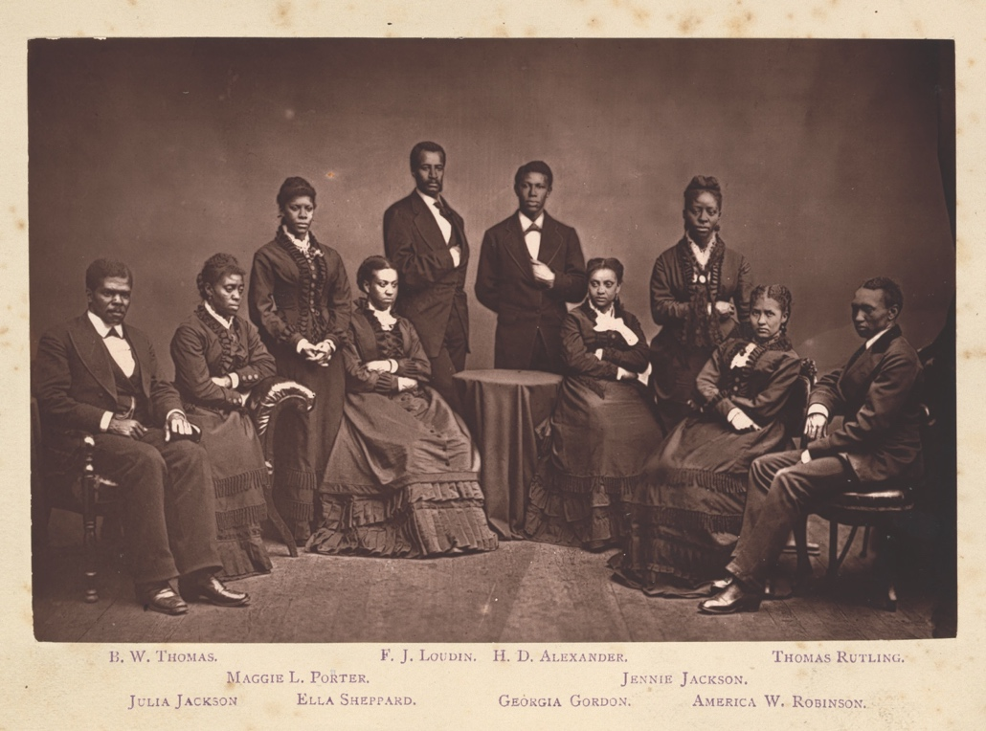
National Portrait Gallery, Smithsonian Institution
On Tuesday the 25th of November 1873, the Fisk Jubilee Singers made their first appearance at Leeds Town Hall. The singing group had come to Britain from Nashville, Tennessee, as representatives of Fisk University. They were on a mission to raise funds for the development of the college, which had been set up in 1866 to provide an education for Tennessee’s newly emancipated African American community, who, at that time, were excluded from existing institutions due to segregation laws.
In the words of The Leeds Mercury: “They represented four millions of freedmen in the Southern States of America, and, more than that, they were promoting a missionary purpose on behalf of the whole negro race in the West Indies and Africa. Their presence reminded us that not very long ago there was on the flag of America the dreadful stain of slavery, which in God’s good providence, overruling the affairs of men, had now been wiped off, freedom being restored to the poor captives.”
The Leeds Mercury, November 26th, 1873
The group first came together in 1871. It was made up of nine singers – four black men (Isaac Dickerson, Greene Evans, Ben Holmes and Thomas Rutling) and five black women (Jennie Jackson, Maggie Porter, Ella Sheppard, Minnie Tate and Eliza Walker). The choir director was George Leonard White, a white music teacher from New York. By the time that they arrived in Britain, the group’s membership had grown to eleven singers. Eight of the members had been formerly enslaved, while the other three had been born to enslaved people.
By the time they came to Britain, their repertoire was well developed and mainly consisted of spirituals – religious songs that were well known to black communities in the United States, but little heard elsewhere, outside of their co-option into minstrel shows. For many British audiences, it was the first time that they had heard black music sung by black singers. The beauty and sincerity of the sound was a revelation, and their songs had a profound influence on European composers of the time. Amongst them was Samuel Coleridge Taylor, who began incorporating African American folk music into his compositions after seeing the Singers perform in the 1890s. He also transcribed several of their songs for piano.
Their concert in Leeds was well-received. The newspaper reports that, “More than half the available space had to be set apart for reserved seats, so large was the sale of tickets, and even after the great hall had been crowded to its utmost capacity the doors were still besieged by persons desirous of admission.”
The Leeds Mercury, November 26th, 1873.
Such was their success that the group embarked on a second European tour in the spring of 1875 and made their return to Leeds Town Hall, in January 1876. Altogether they raised more funds in Yorkshire than anywhere else in Europe over the three years. This led to one of the rooms at Fisk University being named the Wilberforce Room, in honour of Yorkshire’s generosity.
Yorkshire would also become the home of founding member Thomas Rutling. After a career as a solo tenor singer, he became a teacher of foreign languages at a school in Harrogate, where he lived until his death in 1915. He enjoyed fishing locally, wrote his autobiography and chaired a meeting on Woodhouse Lane at the Quaker Meeting House, to welcome African American journalist Ida B Wells.

MUSICAL CONNECTIONS
Apart from those described on other Past and Present posters, Woodhouse and Hyde Park have many other musical connections. Thousands of popular bands and singers have performed at the University of Leeds and Leeds Beckett University over the years, and many others have performed gigs (sometimes for the first time) in local music venues such as Strawbs, The Packhorse, The Eldon, The Faversham and Joseph’s Well, which sadly closed in 2012. Listed below are some of the many other ways in which music has played a part in the life of the area.
● On Valentines Day in 1970, The Who recorded their iconic album Live at Leeds in the refectory of the University of Leeds. The six-track album was released on the 11th of May 1970. It reached number 3 on the UK album charts and is still seen as highwater mark for live recorded music.
● In 1973, reggae superstar Bob Marley played at Leeds Polytechnic (now Leeds Beckett) – a performance that resulted in an unofficial live album being released on the Weeping Goat label. Marley returned to Leeds three years later and performed at the University of Leeds.
● The post-punk band Gang of Four were formed in Leeds in 1976. The band’s guitarist, Andy Gill, was resident in Hyde Park while studying Art at the University of Leeds. As well as his work with Gang of Four, he produced and played on work by many other artists, including Red Hot Chili Peppers, Michael Hutchence, The Stranglers, Killing Joke, The Futureheads, Therapy? and The Jesus Lizard.
● In the late 1970s, singer-songwriter Marc Almond studied Art at Leeds Polytechnic. In 1977, he met musician David Ball, and the duo formed Soft Cell. They went on to have five top ten singles in the early 1980s and hit number one with their cover version of ‘Tainted Love’ in 1981.
● DJ Andy Kershaw came to the University of Leeds in the late 1970s to study politics. He never finished his degree. In his second year, he took on the role of entertainment secretary for Leeds Student Union and spent the rest of his time booking bands. He later worked for Radio Aire and the BBC, presenting shows on Radio One and Radio Three. He is known for his love of world music, soul, reggae and blues.
● Andy Kershaw’s older sister, Liz Kershaw, followed him to Leeds. Like her brother, she later became a DJ for the BBC. She lived in Hyde Park and at one point had a flat on Shire Oak Road, not far from the premises of the Yorkshire College of Music and Drama. She was, for a while in an all-girl singing group called Dawn Chorus and the Blue Tits, with a young Carol Vorderman.
● In 1986, the American singer, writer, actor and spoken-word performer Henry Rollins briefly lived in Hyde Park, following the break-up of his band Black Flag. During this time, he wrote much of the material for his first solo album Hot Animal Machine.
● Singer Corinne Bailey Rae studied English at Leeds University, graduating in the year 2000. She lived in Hyde Park and worked at the Clock Café as a waitress. Her self-titled debut album was released in 2006 and reached number one on the UK album chart.

Concert posters for the University of Leeds Union, 1978-80 © Wingfinger Graphics, Leeds

